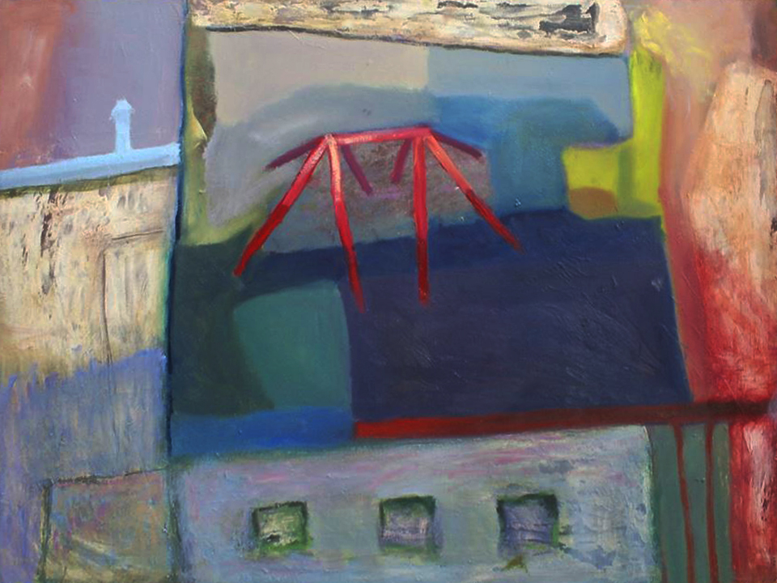
At the beginning of my artistic activity I look around and perceive reality. My inspiration might be really anything if it touches my sensitivity. In my case this step of creative process usually takes the most time, simply because of all the possibilities there are.
My recent long term inspiration are landscapes and cityscapes, especially our city's buildings and their rooftops. When I was still living in the dormitory, we used to go out to the roof. The building is placed in a poor district. It is surrounded by untidy, mostly damaged tenement houses which give a sad impression of decay, but also show a whole spectrum of different tones, colours, textures and shapes to a keen observer. From this high perspective the buildings were merging into disordered mosaic whose appearance varied on weather and time of the day. I just look for an interesting configuration of those shapes and colorful stains. Depending on the tool I currently have, I take a picture or make a quick sketch painting. In the case when I lack a camera or any painting or drawing accessories, I try to remember the image and take a detailed note about it on my mobile phone. It's better than nothing.
When I'm done with the planning phase I pick a painting surface. I prefer a wooden board or a plywood over canvas, especially when it's slightly damaged or already covered with paint. You can take an advantage of it and for example save a lot of time on building textures, which is very efficient, or leave some parts unpainted which gives your work some sort of randomness. Lately I discovered a simple method to build additional textures and layers by covering some parts with transparent glue. Those surfaces are smooth in touch but have a rough, teary look, a perfect background for glazes. It's very quick and effective way to give a painting some formal depth and drama.
In my paintings I try to reduce the observed objects, scenes to flat color stains that work with varied tones, temperatures and textures. They are the carriers of emotions and mood in my paintings. I disrupt reality to the point when it gets an abstractive overtone. I'm very focused on making it look integral and balanced, make all its parts work as one. It's important to me that the viewer isn't able to point a single part of it that doesn't fit to the whole. This is what I consider the most important feature in my paintings.

Grzegorz Strongowski

